Git diff is the command to compare the differences with the copies on repository to the working area copy.

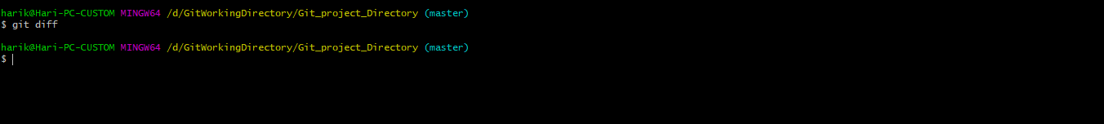

Looks like here there is no differences for my repository copy and working area, but issue the command git status now

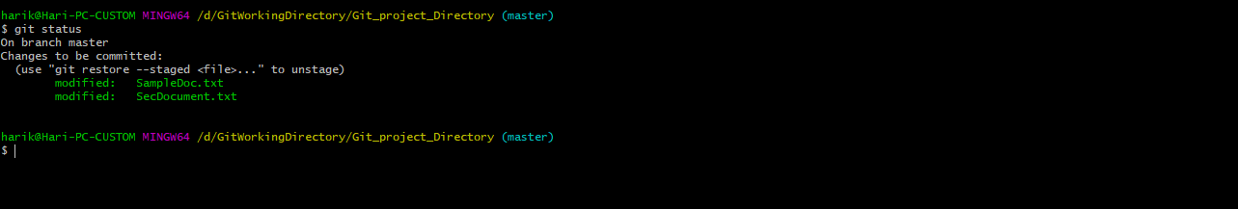

You can see still the modified changes are not committed, which is not present in local repository.

Now how will you see the differences in local repository? You need to issue the below command to see the differences with local repository copy with staging area

# git diff --staged

